*Florida International University*

*School of Computing and Information Sciences*

CIS 4911 - Senior Capstone Project

Software Engineering Focus

Feature Document

User Story # 670

**Team Member:**

Garrett Lemieux

**Product Owner(s)**:

Francisco Ortega

**Mentor(s)**:

Francisco Ortega

**Instructor**: Masoud Sadjadi

**User Story – Implement “Undo” button**

* As a User I would like to be able to restore previous drawn states in order to allow mistakes to be made and further development on canvas.
* **Acceptance Criteria**:
  1. User must be able to undo or restore previous draw state.
  2. User must be able to select this option using UI.

**Use Case**

User wants to undo a previously drawn line or shape from current canvas.

* Details:
* Actor:
  + User
* Pre-conditions:
  + TouchPoint app is running.
  + MultiTouch screen connected.
* Description:
  + Use case begins when User has decided to undo a previously drawn line or shape.
  + User undoes a drawn line or shape by pressing last button on the right of set of buttons in left hand corner of screen.
  + Use case ends when previously drawn line or shape is removed.
* Post-conditions:
  + TouchPoint app is running.
  + MultiTouch screen connected.
* Decision Support:
  + Frequency: High, User constantly alters canvas and may make mistakes.
  + Criticality: High, User must be allowed to fix mistakes.
  + Risk: Medium
* Constraints:
* Usability:
  + Need to know which buttons performs undo function.
* Reliability
  + High
* Performance
  + Performance High
  + Failure Low
* Supportability
  + Multi-Touch Screen (ACER)
  + Real Sense
* Modification History:
  + Owner: Garrett Lemieux
  + Initiation Date 03/24/2016
  + Date last Modified: 04/03/2016

**Use Case Diagram**

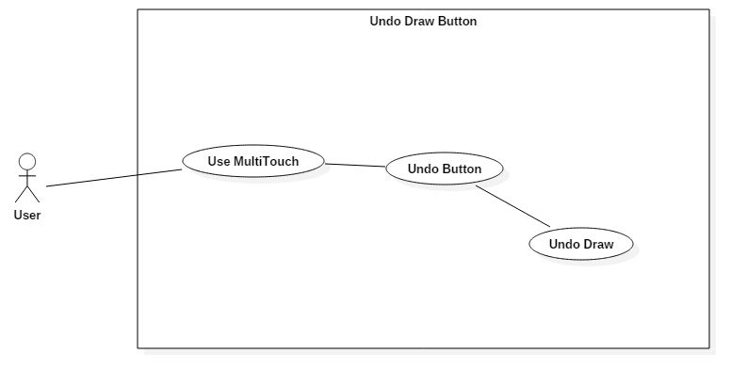

**Sequence Diagram**

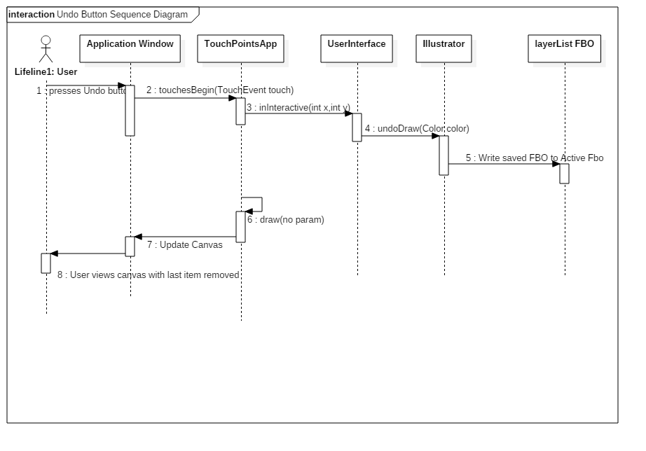

**Class Diagram**

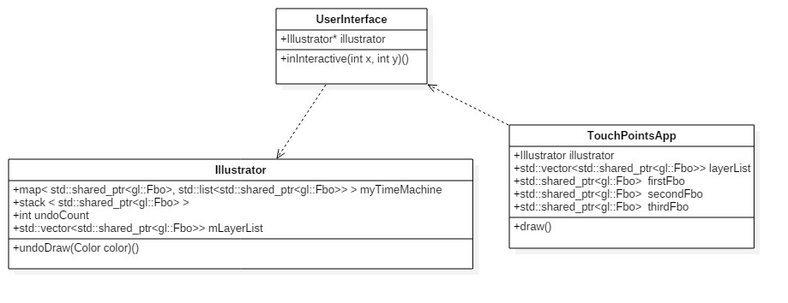

**Unit Test**

* Sunny Day Test:
  + Test Case  - User wants to undo multiple drawn lines or shapes
    - Test Purpose: To determine if user can undo a previously drawn line or shape.
    - Test Procedure: User starts program and draws three lines or three shapes starting from the left side of canvas. He or she then presses the undo button once. Observes results then presses undo button a second time. Observes results and then presses undo button a final time and observes results.
    - Expected Results: After undo button pressed for the first time the line or shape farthest to the right should disappear. After second time undo button pressed line or shape farthest to the right should disappear. After the button is pressed a third times all lines and shapes should have been removed.
* Rainy Day Test:
  + Test Case  - User presses undo button when no lines or shapes drawn
    - Test Purpose: Test undo button works correctly if no lines or shapes drawn and button pressed.
    - Test Procedure: User starts program and immediately without drawing anything presses undo button.
    - Expected Results: Nothing should happen since no lines or shapes drawn. If anything changes in the program test fails.
  + Test Case  - User trys to undo more line or shapes than undo limit
    - Test Purpose: Test undo button works correctly if 11 lines or shapes drawn and button pressed 11 times.
    - Test Procedure: User starts program and draws 11 lines or 11 shapes starting from the left side of canvas. He or she then presses the undo button 11 times in a row and observes result.
    - Expected Results: One line or shape should remain since the undo limit is set to 10 items. If more or less than one line or shape occurs than test fails.

**Integration Testing**

* The ability to use the “undo” button while all devices are connected is successful. User may use “undo” button with multitouch screen or Real Sense device.
* The undo button was tested with all shapes and all the colors.
* The undo button was also tested with the different layers. Each layer was tested individual and then switch between the layers and further tested the “undo” button.
* After integrating “undo” button into the application all previous functionality was maintained and functioning correctly.

**User Guide**

* Devices Used: Acer Multitouch
* 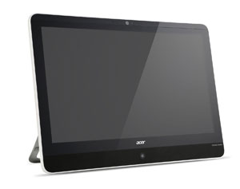
* User can remove drawn line or shape by pressing the undo button
* The undo button is located in the upper left hand corner of the canvas. The button has not icon and takes the color of the background.

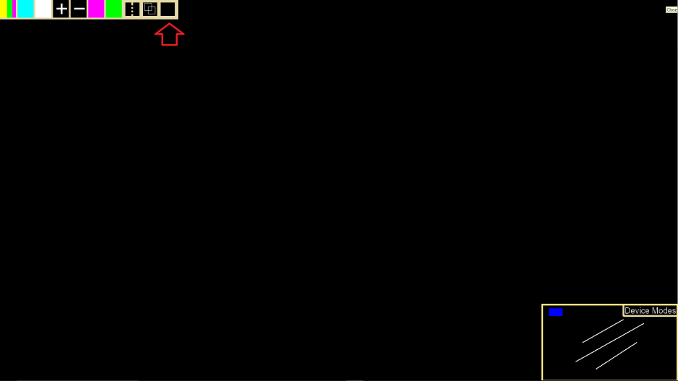

* In order to remove a previously drawn line or shape the user presses the button.
* Before undo button is pressed

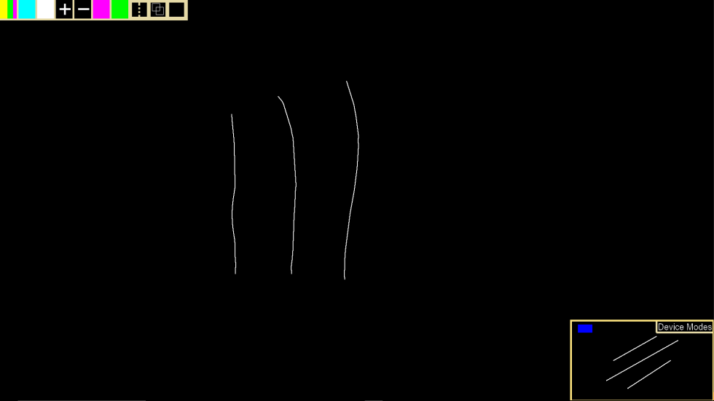

* After undo button is pressed

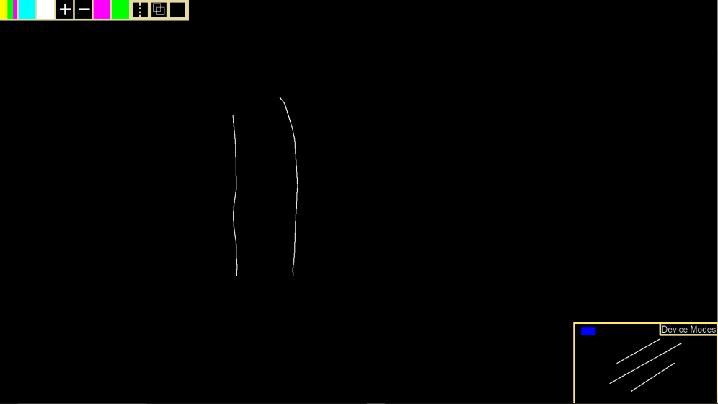

* The user can remove up to ten drawn lines or shapes.

**Glossary**

* **Undo Function** - removes previously drawn shapes or lines from canvas on current layer.